**ATTENDANCE SYSTEM**

**Rodin E-Systems**

**Entity Relationship Diagram**

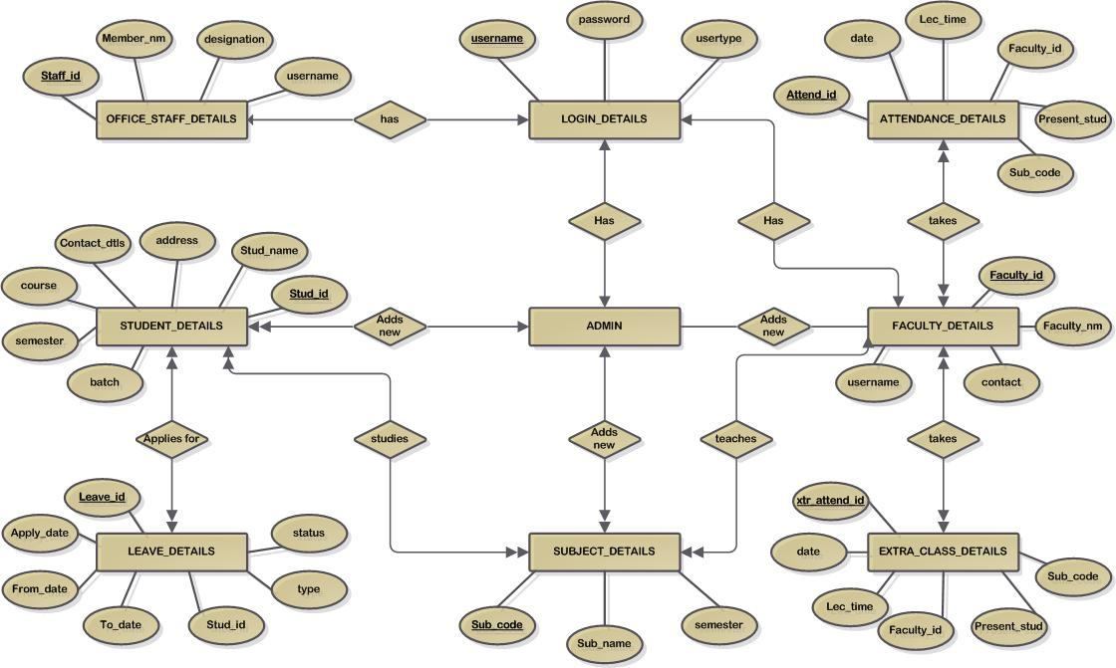**Data Dictionary**

In [database management system](http://www.webopedia.com/TERM/D/database_management_system_DBMS.html) Data Dictionary is a [file](http://www.webopedia.com/TERM/D/file.html) that defines the basic organization of a [database](http://www.webopedia.com/TERM/D/database.html). A data dictionary contains a list of all files in the database, the number of [records](http://www.webopedia.com/TERM/D/record.html) in each file, and the [names](http://www.webopedia.com/TERM/D/name.html) and types of each [field](http://www.webopedia.com/TERM/D/field.html). Most database management systems keep the data dictionary hidden from [users](http://www.webopedia.com/TERM/D/user.html) to prevent them from accidentally destroying its contents. Data dictionaries do not contain any actual [data](http://www.webopedia.com/TERM/D/data.html) from the database. Without a data dictionary, however, a database management system cannot [access](http://www.webopedia.com/TERM/D/access.html) data from the database.

1. **Login Table**

**Description:** Login table stores details for authentication

|  |  |  |  |
| --- | --- | --- | --- |
| **Sr. no** | **field name** | **data type** | **description** |
| 1. | Username | varchar2(30) | Primary Key |
| 2. | Password | varchar2(20) |  |
| 3. | Usertype | varchar2(10) |  |

1. **Student details**

**Description:** Stores students’ details

|  |  |  |  |
| --- | --- | --- | --- |
| **Sr. no** | **field name** | **data type** | **description** |
| 1. | stud_id | varchar2(5) | Primary Key |
| 2. | Stud_name | varchar2(40) |  |
| 3. | Address | varchar2(50) |  |
| 4. | contact_details | varchar2(12) |  |
| 5. | Course | varchar2(3) |  |
| 6. | Semester | number |  |
| 7. | Batch | varchar2(9) | eg : 2009-2012 |

1. **Faculty details**

**Description:** Stores faculties’ details

|  |  |  |  |
| --- | --- | --- | --- |
| **Sr. no** | **field name** | **data type** | **description** |
| 1. | faculty_id | varchar2(5) | Primary Key |
| 2 | faculty_name | varchar2(50) |  |
| 3. | contact_details | varchar2(40) |  |
| 4. | Username | Varchar2(30) | Foreign Key |

1. **Office staff details**

**Description:** Stores office staff members’ details

|  |  |  |  |
| --- | --- | --- | --- |
| **Sr. no** | **field name** | **data type** | **description** |
| 1. | staff_id | varchar2(5) | Primary Key |
| 2 | member_name | varchar2(50) |  |
| 3. | designation | varchar2(40) |  |
| 4. | Username | Varchar2(30) | Foreign Key |

1. **Attendance details**

**Description:** Stores attendance details

|  |  |  |  |
| --- | --- | --- | --- |
| **Sr. no** | **field name** | **data type** | **description** |
| 1. | attend_id | varchar2(5) | Primary Key |
| 2 | Date | date/time |  |
| 3. | Time | varcahr2(10) |  |
| 4. | faculty_id | varchar2(5) |  |
| 5. | present_students | varchar2(MAX) | All the present students’ id are stored as a string  Eg : “1-2-5-8-10-11” |
| 6. | sub_code | varchar2(5) |  |

1. **Subject details**

**Description:** Stores attendance details for the extra classes taken

|  |  |  |  |
| --- | --- | --- | --- |
| **Sr. no** | **field name** | **data type** | **description** |
| 1. | sub_code | varchar2(5) | Primary Key |
| 2 | sub_name | varchar2(50) |  |
| 3. | semester | varchar2(5) |  |

1. **Extra Class Attendance details**

**Description:** Stores attendance details for the extra classes taken

|  |  |  |  |
| --- | --- | --- | --- |
| **Sr. no** | **field name** | **data type** | **description** |
| 1. | attend_id | varchar2(5) | Primary Key |
| 2 | Date | date/time |  |
| 3. | Time | varcahr2(10) |  |
| 4. | faculty_id | varchar2(5) |  |
| 5. | present_students | varchar2(MAX) | All the present students’ id are stored as a string  Eg : “1-2-5-8-10-11” |
| 6. | sub_code | varchar2(5) |  |

1. **Leave details**

**Description:** Stores leave details

|  |  |  |  |
| --- | --- | --- | --- |
| **Sr. no** | **field name** | **data type** | **description** |
| 1. | Leave_id | varchar2(5) | Primary Key |
| 2 | Date | date/time |  |
| 3. | From_date | Date/time |  |
| 4. | to_date | Date/time |  |
| 5. | Stud_id | varchar2(5) |  |
| 6. | Type | varchar2(10) | i.e. : Medical or General |
| 7. | Status | Boolean | Approved – True  Not Approved – False |